

Experiment No.: 03

Title: Jenkins installation
Batch: B–1 Roll No.: 16010422234 Experiment No.: 03
______________________________________________

Aim: Installation of Jenkins for windows/Ubuntu
______________________________________________

Resources needed: Internet
______________________________________________

Theory:

Jenkins is an open-source automation server written in Java. It is used to continuously build and test software projects, enabling developers to set up a CI/CD environment. It also supports version control tools like Subversion, Git, Mercurial, and Maven. Jenkins achieves Continuous Integration with the help of plugins. Plugins allow the integration of various DevOps stages. To integrate a particular tool, you need to install the plugins for that tool. For example, Git, Maven 2 project, Amazon EC2, HTML publisher etc. It is built with Java and hence, it is portable to all the major platforms.

Jenkins features:
- Adoption: Jenkins is widespread, with more than 147,000 active installations and over 1 million users around the world.
- Plugins: Jenkins is interconnected with well over 1,000 plugins that allow it to integrate with most of the development, testing and deployment tools.
______________________________________________

Procedure:
- Check machine virtualization is ON.
- Download and install the latest version of Docker Desktop for Windows.
- Follow the usual installation instructions to install Docker Desktop. Depending on which version of Windows you are using, Docker Desktop may prompt you to turn on WSL 2 during installation. Read the information displayed on the screen and turn on the WSL 2 feature to continue.
- Start Docker Desktop from the Windows Start menu and minimize it.
- Start cmd or powerShell and Install Jenkins in docker [ reference 1].
______________________________________________

Results: (Document with screenshots)
- All steps of installation
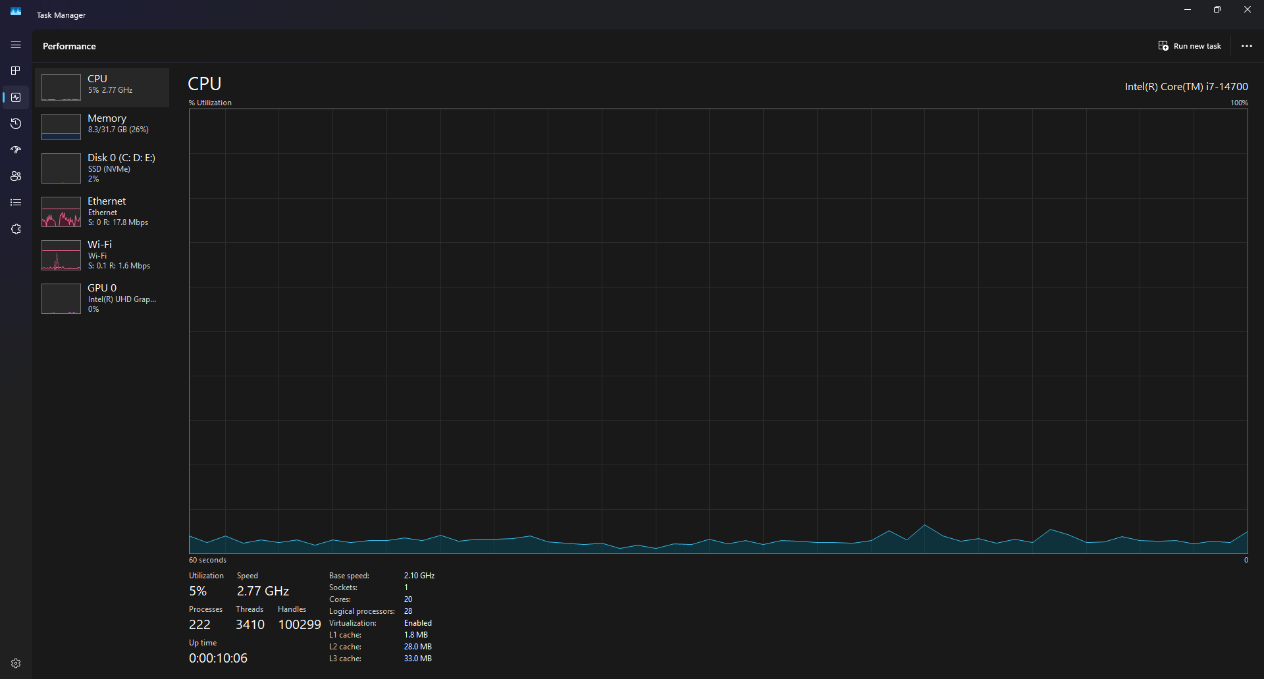

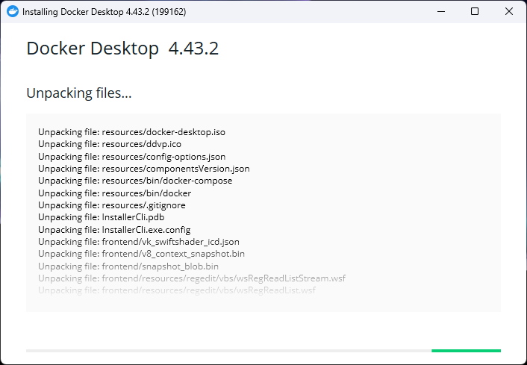
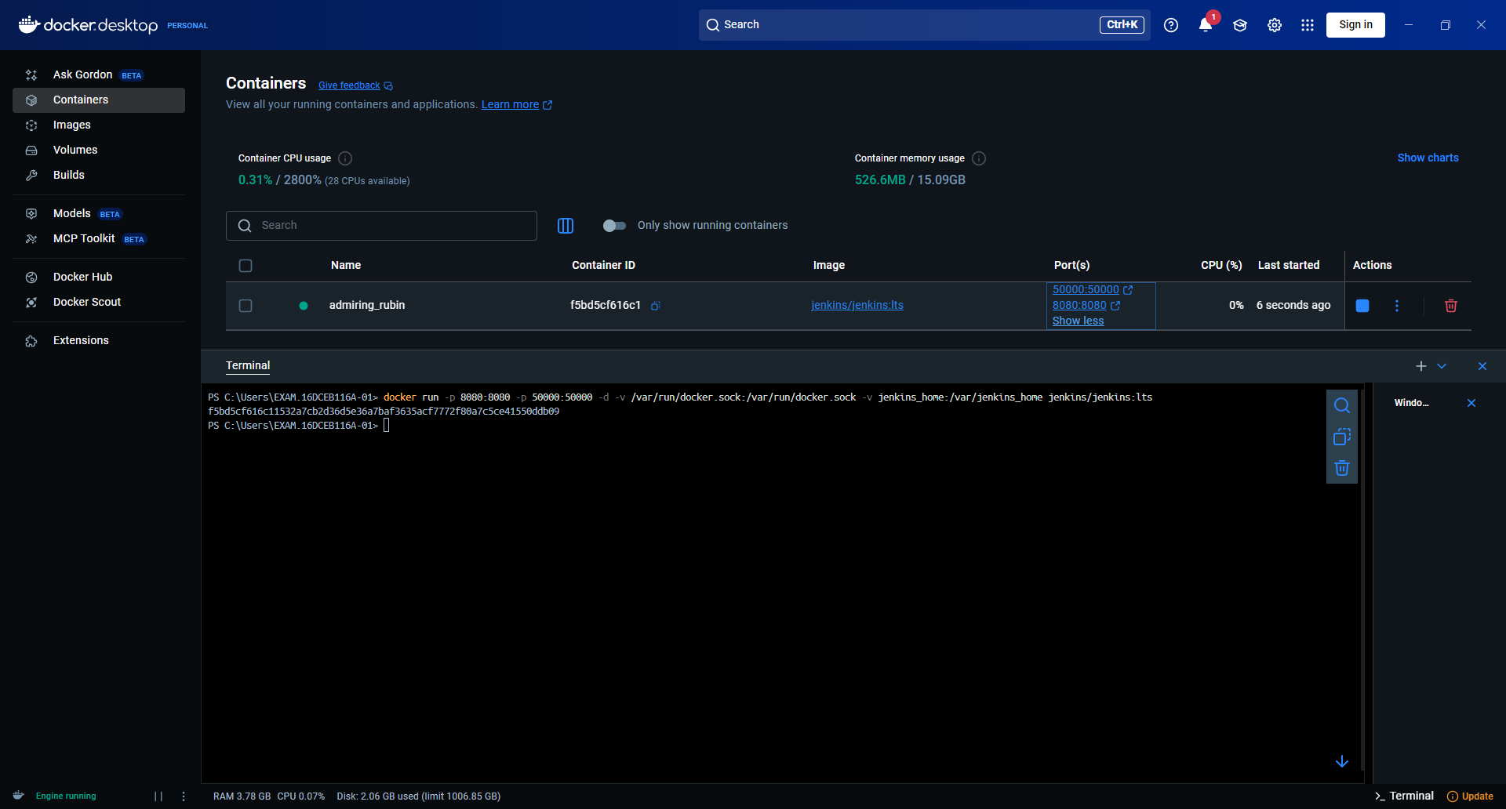

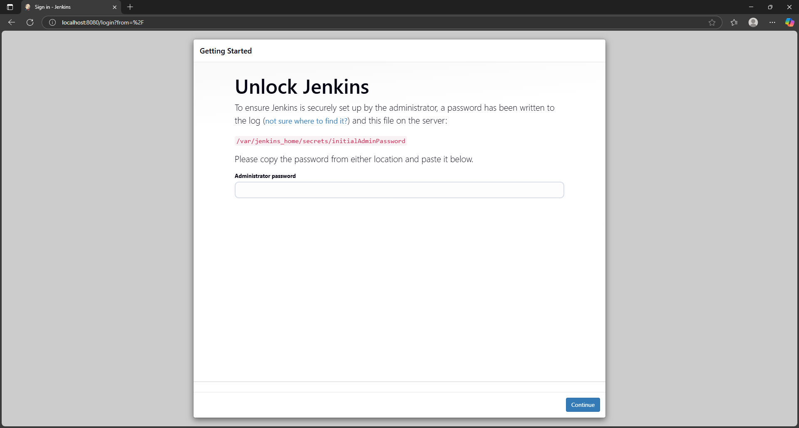
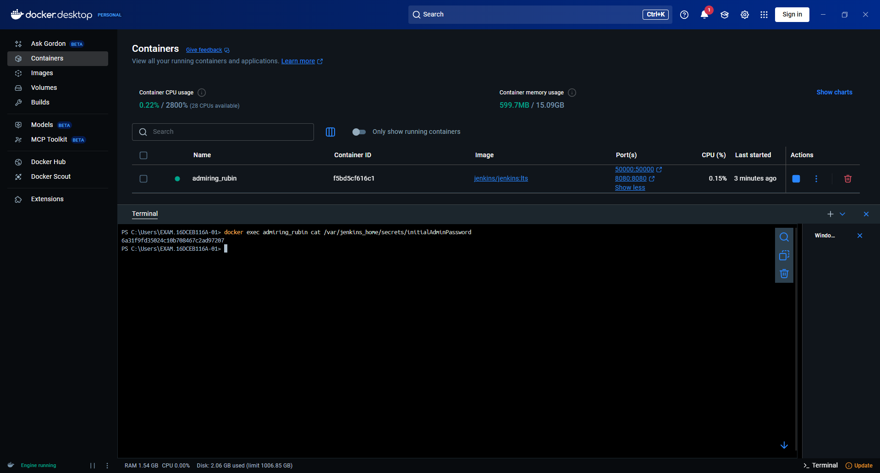

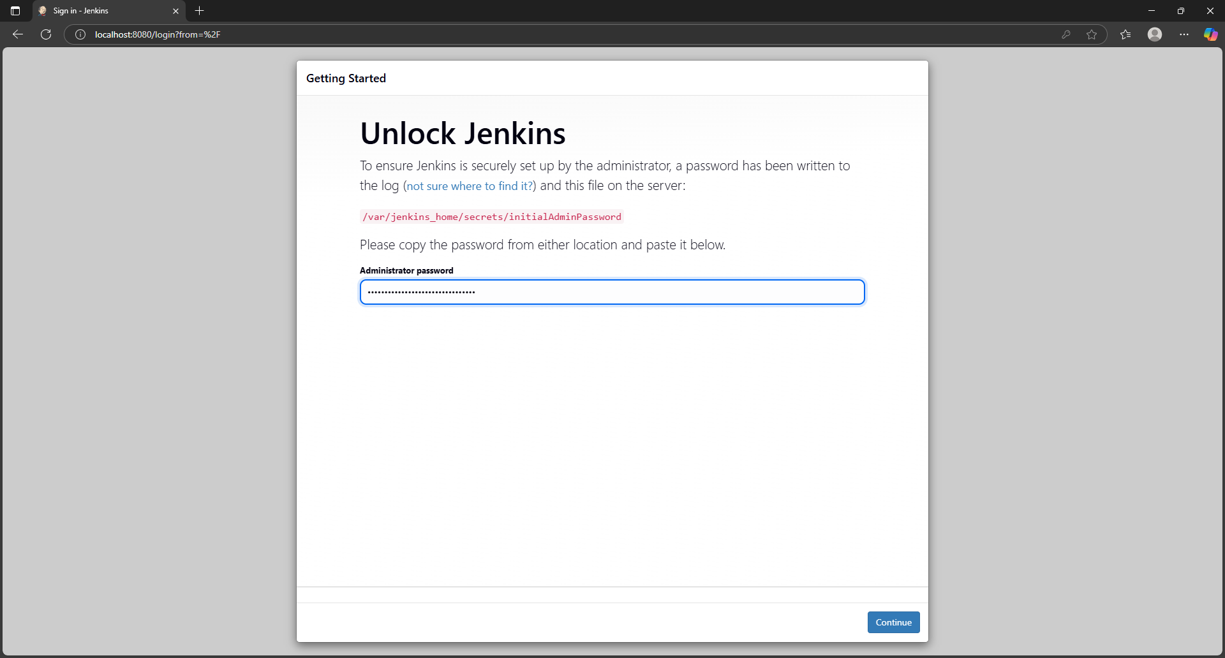
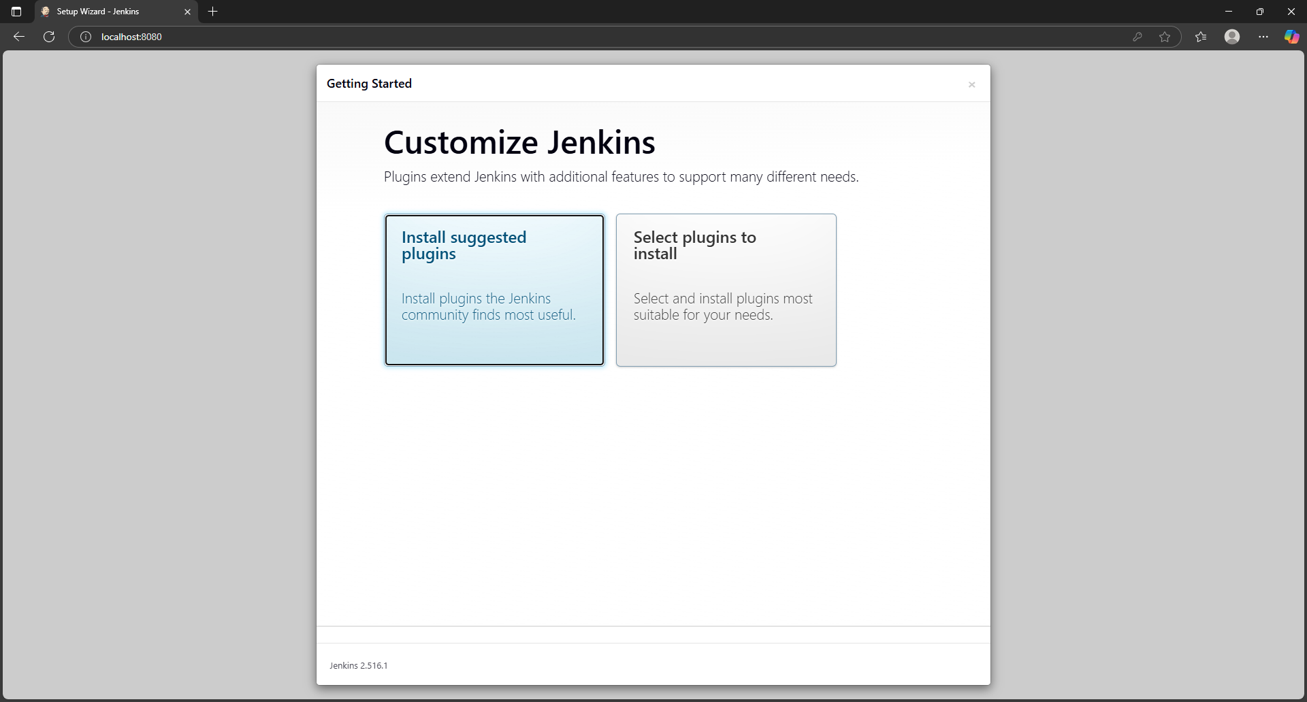

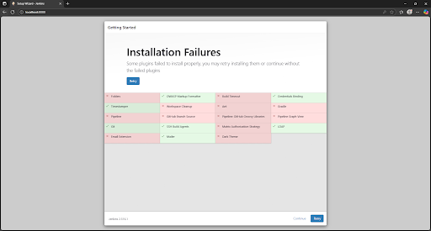
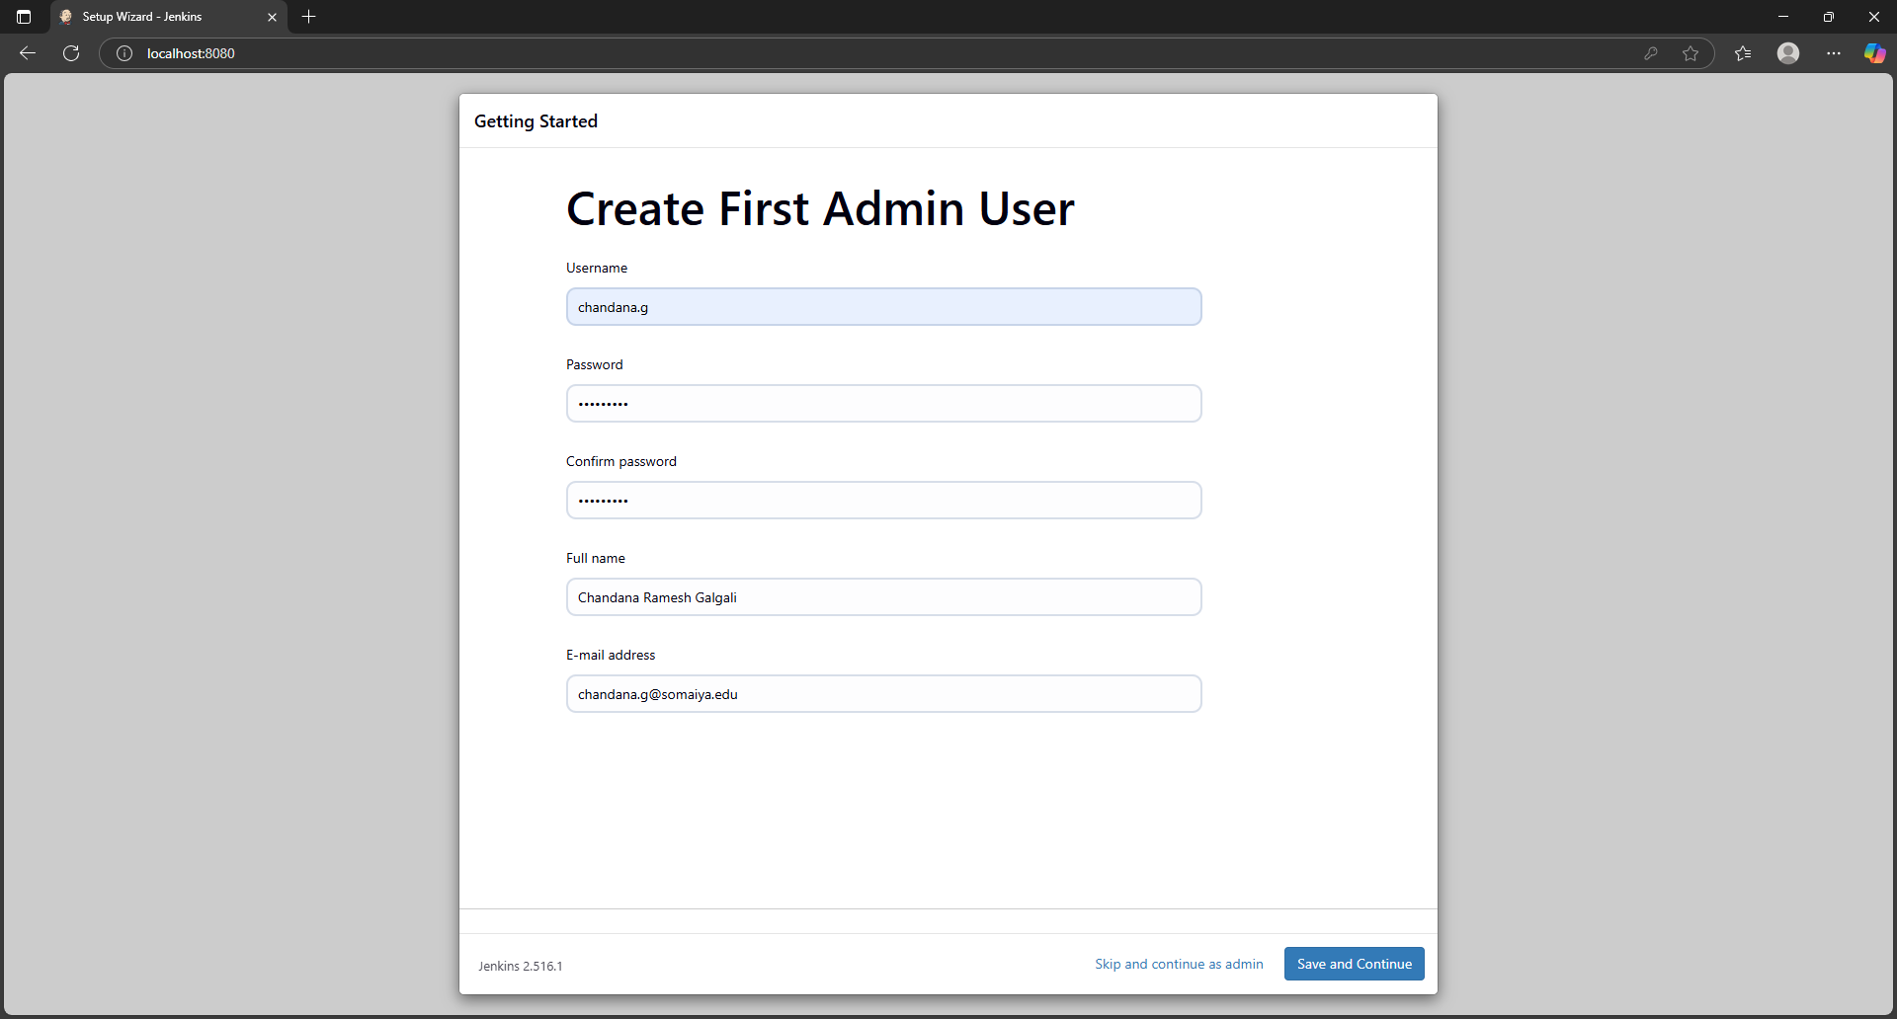

- Jenkins dashboard

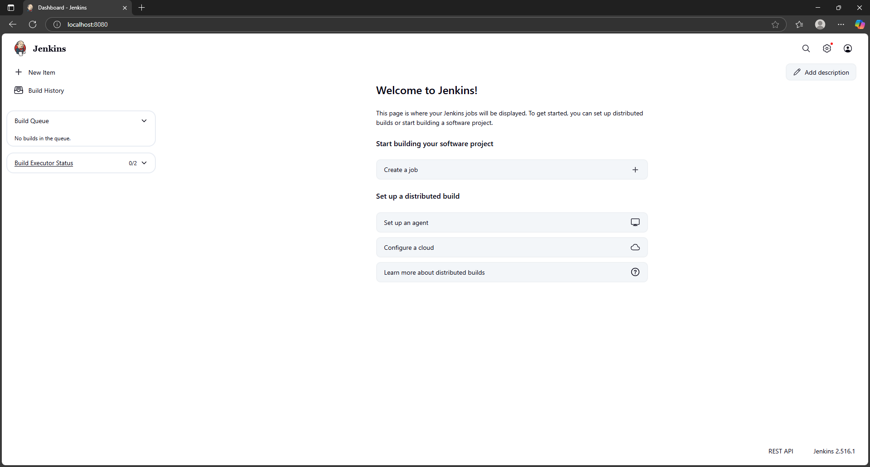
______________________________________________
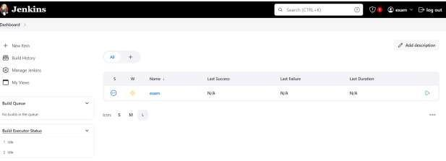
Figure 1: Jenkins Dashboard

Questions:
- Explain various options/features of Jenkins dashboard
Ans: The Jenkins Dashboard provides the main interface for managing jobs and monitoring builds. Key features:
- New Item: Create new jobs (Freestyle, Pipeline, Multibranch Pipeline, etc.).
- People: Displays users and their activities.
- Build History: Shows a timeline of recent builds.
- Manage Jenkins: Admin section for configuring system settings, plugins, security, etc.
- My Views: Allows users to create custom views for specific jobs.
- Credentials: Manage stored credentials (API keys, SSH keys, etc.).
- Nodes: View and manage agents (nodes) for distributed builds.
- Queue: Displays jobs waiting to run.
- Log Output: For each job, logs are available to debug or audit build activity.
- Plugins: Access to install and manage over 1000 plugins to extend Jenkins functionality.
______________________________________________

Outcomes: CO3 – Comprehend the effective code building and testing process
______________________________________________

Conclusion: (Conclusion to be based on the Results and outcomes achieved)
In this experiment, Jenkins was successfully installed using Docker on Windows/Ubuntu. The Jenkins Dashboard was accessed and set up to manage jobs and pipelines efficiently. The experiment helped in understanding Continuous Integration and the automation of the software build and testing process. The dashboard provides a user-friendly interface to monitor build statuses, manage users, configure tools, and extend functionality with plugins.
______________________________________________

Grade: AA / AB / BB / BC / CC / CD / DD

Signature of faculty in-charge with date
______________________________________________

References:
Books/ Journals/ Websites:
- https://faun.pub/jenkins-in-docker-docker-running-inside-a-jenkins-container- 6d02ec41b055
- Effective DevOps: Building a Culture of Collaboration, Affinity, and Tooling at Scale, Jennifer Davis, Ryn Daniels, O'Reilly Media June 2016.
- Practical DevOps: Implement DevOps in your organization by effectively building, deploying, testing, and monitoring code,Joakim Verona, Packt Publishing, 2nd Edition,2016
______________________________________________

